Handout no. 5

|  |  |
| --- | --- |
| **Name** | Ahmad Bandesha, Faizan Azam, Muhammad Asad |
| **Reg. No** | 2019-EE-373, 2019-EE-381, 2019-EE-383 |
| **Marks/Grade** |  |

**EXPERIMENT # 5**

**Perform Economic Dispatch operation of Generators in Power system**

**Objective:**

At the end of this lab session students will be able

* To analyse Power system operations in Power World Simulator.
* To accurately perform operation of economic dispatch mathematically and in PWS.

**Introduction:**

Economic dispatch operation is a process used in power systems to allocate generation among available power sources in a manner that minimizes the overall cost of producing electricity while satisfying system-wide demand.

Economic dispatch is an important aspect of power system operation as it ensures that the system is operated efficiently, minimizing the cost of producing electricity and ultimately leading to lower electricity prices for consumers. It is typically carried out by a centralized control center, which monitors system demand and generator output levels and adjusts them as necessary to ensure the most efficient and cost-effective operation of the system.

**Simulation:**

**Demand 1160MW:**

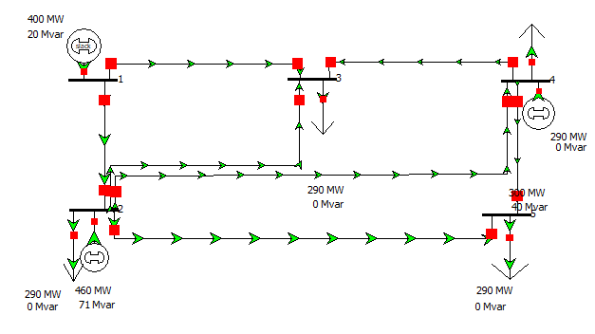

**Figure No 1:PWS model**

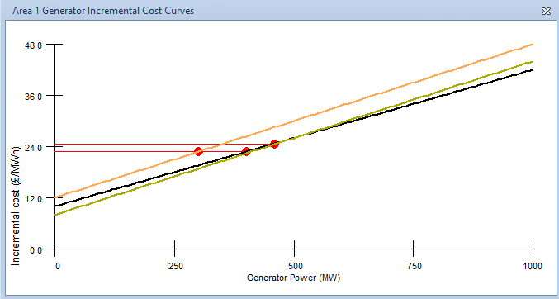

**Figure No 2: Increamental cost curves**

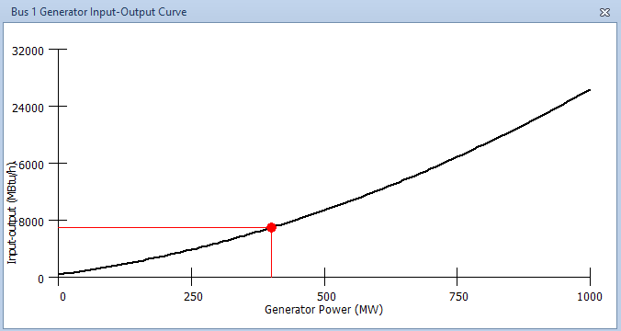

**Figure No 3: Input-output curve**

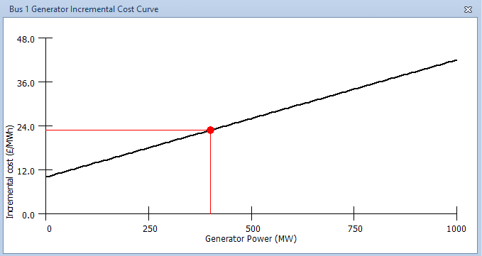

**Figure No 4: Increamental cost curve**

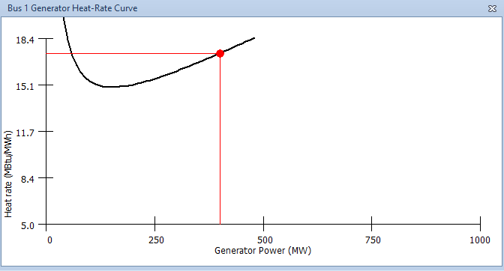

**Figure No 5: Heat rate curve**

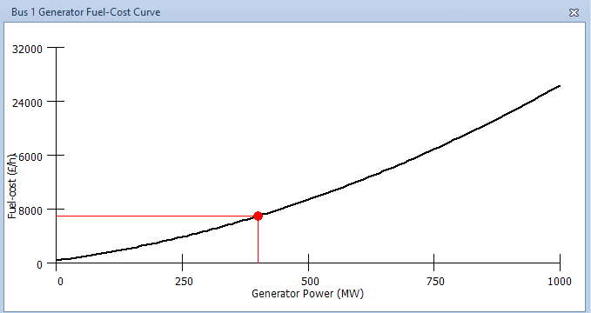

**Figure No 6: Fuel cost curve**

**Demand 654MW:**

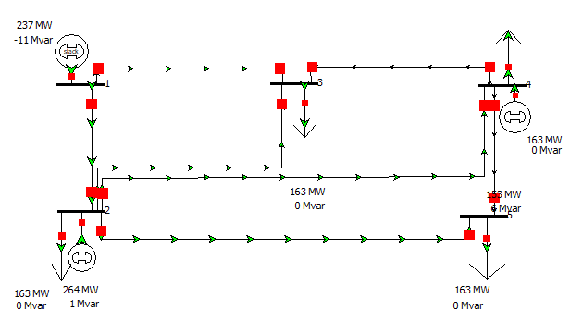

**Figure No 7:PWS model**

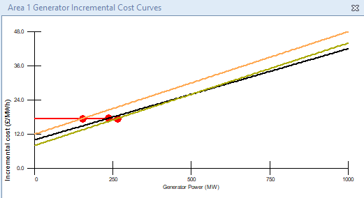

**Figure No 8: Increamental cost curves**

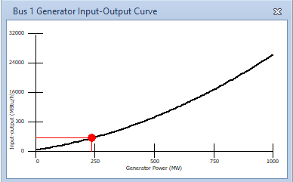

**Figure No 9: Input-output curve**

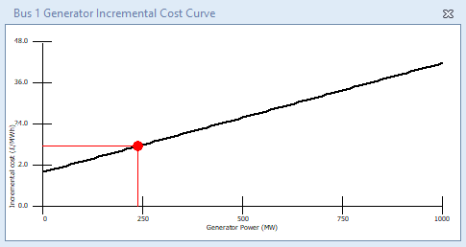

**Figure No 10: Increamental cost curve**

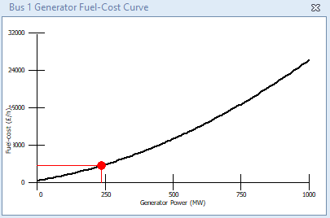

**Figure No 11: Fuel cost curve**

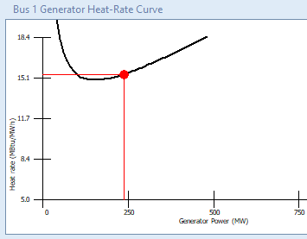

**Figure No 12: Heat rate curve**

**Demand 300MW:**

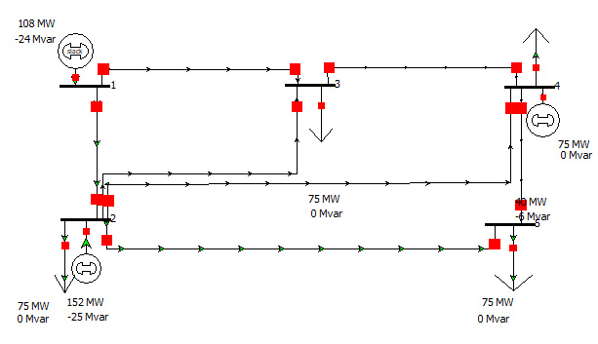

**Figure No 13: PWS model**

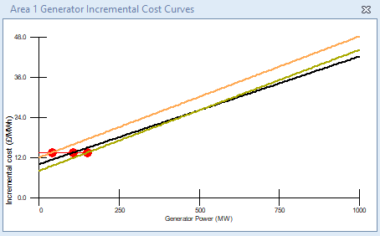

**Figure No 14: Increamental cost curves**

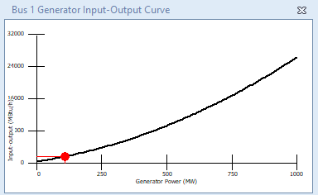

**Figure No 15: Input-output curve**

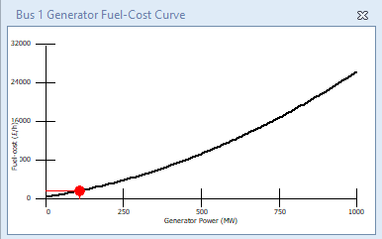

**Figure No 16: Fuel cost curve**

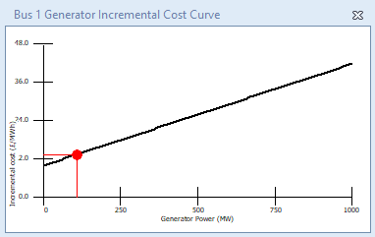

**Figure No 17: Increamental cost curve**

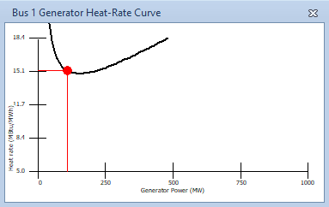

**Figure No 18: Heat rate curve**

**Mathematical Calculations:**

**Observation and Conclusion:**

The economic dispatch problem can be formulated as an optimization problem, where the objective function is to minimize the total cost of generating power subject to various constraints. Different algorithms and techniques can be used to solve the economic dispatch problem, such as the lambda iteration method, gradient-based methods, and heuristic algorithms like genetic algorithms or particle swarm optimization.In the lab experiment, the economic dispatch problem have been solved using iterative method, and the results obtained would depend on the specific assumptions and parameters used in the experiment. Overall, the lab experiment provided a practical understanding of the economic dispatch problem and its solution method, and highlighted the importance of efficient power system operation for reducing operating costs and providing reliable and affordable electricity to consumers.